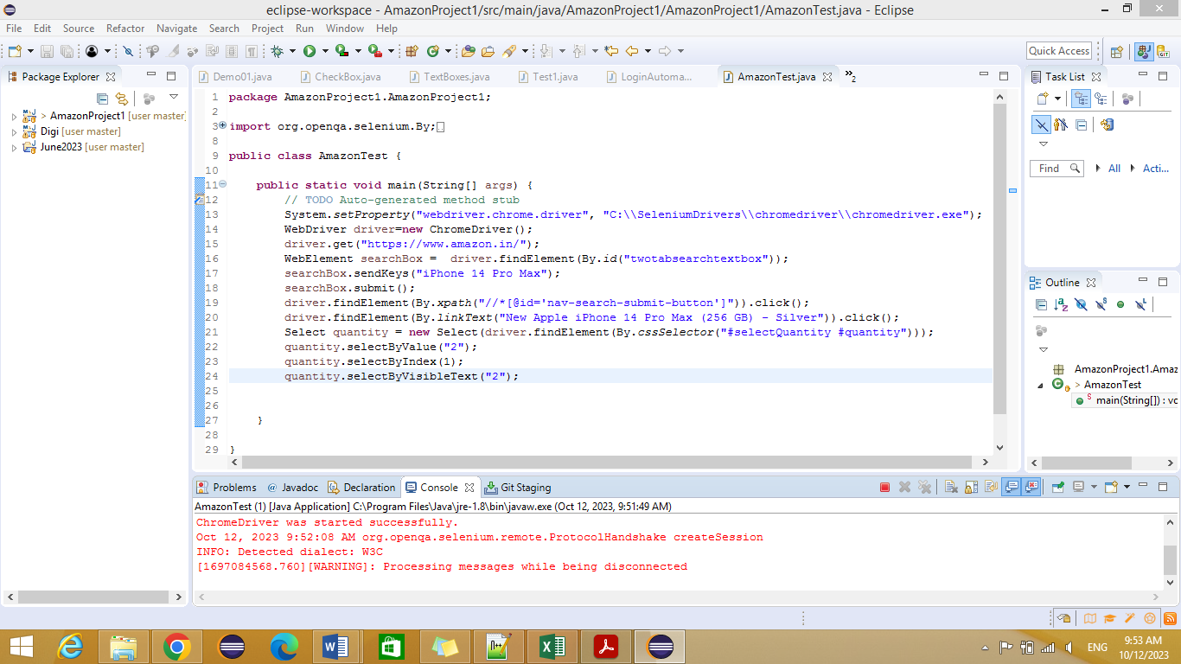

package AmazonProject1.AmazonProject1;

import org.openqa.selenium.By;

import org.openqa.selenium.WebDriver;

import org.openqa.selenium.WebElement;

import org.openqa.selenium.chrome.ChromeDriver;

import org.openqa.selenium.support.ui.Select;

public class AmazonTest {

public static void main(String[] args) {

// TODO Auto-generated method stub

System.setProperty("webdriver.chrome.driver", "C:\\SeleniumDrivers\\chromedriver\\chromedriver.exe");

WebDriver driver=new ChromeDriver();

driver.get("https://www.amazon.in/");

WebElement searchBox = driver.findElement(By.id("twotabsearchtextbox"));

searchBox.sendKeys("iPhone 14 Pro Max");

searchBox.submit();

driver.findElement(By.xpath("//\*[@id='nav-search-submit-button']")).click();

driver.findElement(By.linkText("New Apple iPhone 14 Pro Max (256 GB) - Silver")).click();

Select quantity = new Select(driver.findElement(By.cssSelector("#selectQuantity #quantity")));

quantity.selectByValue("2");

quantity.selectByIndex(1);

quantity.selectByVisibleText("2");

}

}